DEVELOPING WEB APPLICATION USING NODE RED

|  |  |
| --- | --- |
| Team ID | PNT2022TMID00928 |
| Project Name | Smart waste management system for metropolitan cities |

1 . Using Node RED to create a Web UI

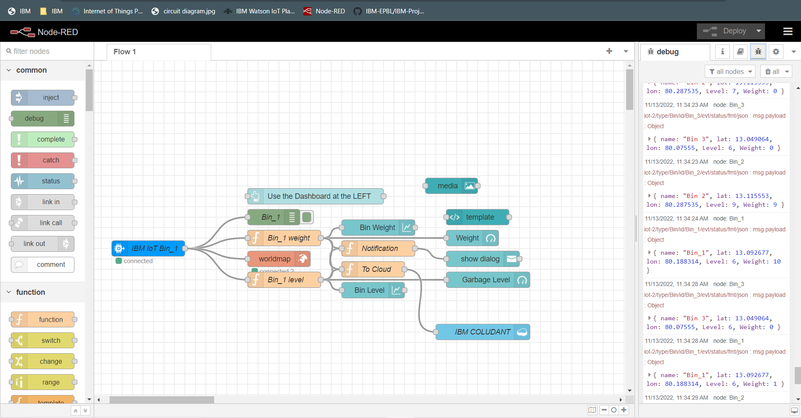

2.Web UI interface

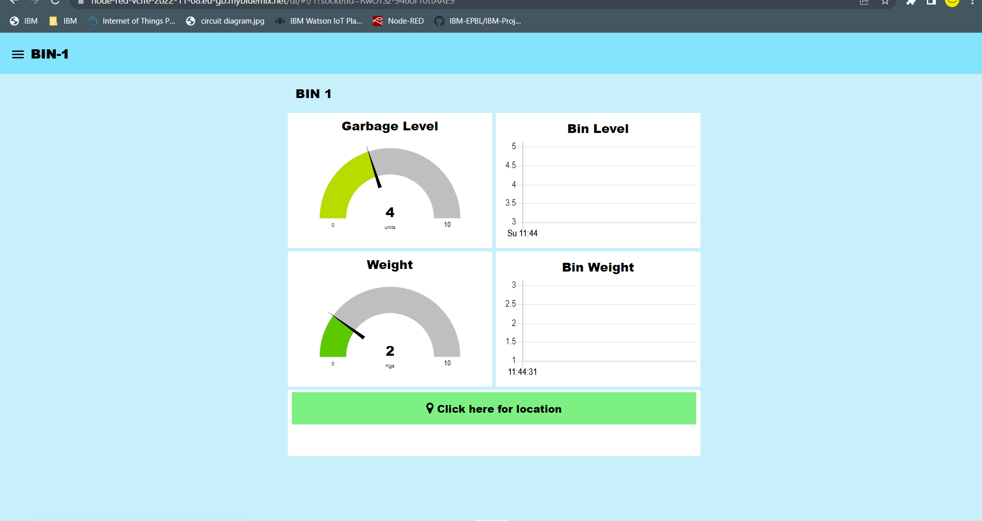

3. Alert message when bin is full

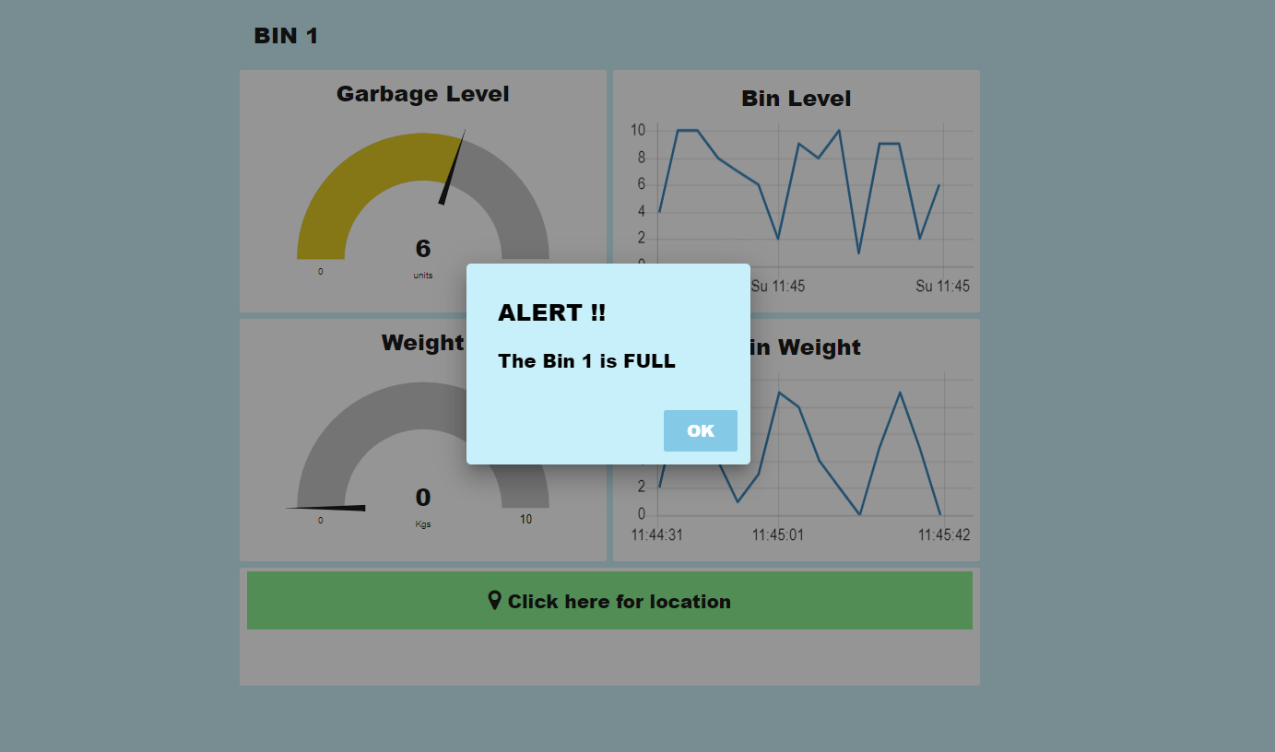

4.Details of bin stored in IBM cloud from Web UI

